CLIENT Iran:

Report Specifications, KPI Definitions, and Report Algorithms

Appendix 3 to Functional Specification

File: CIT.CRM.FSDS.App.Inception.v.1.0.CLIENT.IR

D3S Record:

**Inception CRM** (rebranded from Inception CRM; custom build, eluzzion core)

Functional and Design Specification

Doc. ID.: CIT.CRM.FSDS.Reports.Inception.v.1.0.CLIENT.IR

Version: 1.0

|  |  |  |  |
| --- | --- | --- | --- |
| **Author** | **Version** | **Date** | **Comment** |
| Joshua Mensch | 001 | 30-07-2019 | Appended to file: CIT.CRM.FSDS.App.Inception.v.1.0.CLIENT.IR |
| Joshua Mensch | 002 | 30-07-2019 | Internal version |
| CLIENT | 003 | 05-08-2019 | Revised with some clarifications |
| Joshua Mensch | 004 | 05-08-2019 | Internal version |
| Joshua Mensch | 005 | 19-08-2019 | Revised with addition of new outputs in ETE Report |
| Joshua Mensch | 006 | 23-08-2019 | Addition of GPS Compliance Report |
| Joshua Mensch | 007 | 05-09-2019 | Updated description of Matrix Report |
| Joshua Mensch | 008 | 31-10-2019 | Updated description of GPS Compliance Report |
| Joshua Mensch | 009 | 18-12-2019 | Updated method for calculating Coaching Day |

Contents

1 Business Roles and Definitions 3

2 Report Baselines 5

2.1 Location of the Reports 5

2.2 Common Data and Report Algorithm Definitions 5

2.2.1 Rep Target Call Rates Per Line 5

2.2.2 FLM Target Coaching Rates (Max Values) Per Line 5

2.2.3 Coaching % Calculation Logic 5

2.2.4 Coaching % Calculation Math: 7

2.2.5 KPI Definitions and Calculation Methods 8

3 Report Specifications 24

3.1 “KPI Report” Specifications 24

3.2 “ETE Report” Specifications 26

3.3 “First Opened Day” Specifications 27

3.4 “Matrix Report: Key Messages” Specifications 28

3.5 “Cycle Plan Review” Specifications 30

3.6 “BA Sales Plan Performance” Specifications 31

3.7 “BA Dashboard” Specifications 32

3.8 “GPS Location Compliance” Specifications 33

3.9 “Monthly Distribution Tracker” Specifications 34

3.10 “Monthly Samples Reconciliation” Specifications 34

3.11 “Sample Acknowledgement Letters” Specifications 34

3.12 “Sample Recall Distribution Report” Specifications 35

3.13 “Rep WH Stock Transfer Report” Specifications 35

4 Sample Acknowledgement Letter 36

4.1 Content of the Letter - Persons 36

4.2 Content of the Letter - Institutions 37

5 Rep WH Transfer Receipt 38

a. Content of the Letter - Representatives 38

# Business Roles and Definitions

## Actors

There are three main end-user roles within the field-level application:

* Representatives (Rep)
* Team Leaders (TL)
* Second Line Managers (SLM)

## Description of Roles

### Rep Role

* **Responsibilities:** Reps are responsible for entering data in the system in the form of activity plans, cycle plans, sample drops, and call reports, that reflect their daily tasks and responsibilities.
* **System Usage:** Reps conduct their work using the system's Tablet Client application.
* **Primary Data Entry:** Target Group Creation / Cycle Planning; Customer Visit Frequency Setting (temporary basis); Activity Scheduling; Call Reporting / Profiling; Sample Reporting; Update Requests.
* **Main System Actions:**

1. Log in to the Tablet Client Application and access / use all modules described in the functional specifications;
2. View personal performance KPIs using the Dashboard module

### TL Role

* **Responsibilities:** TLs are responsible for reviewing Rep cycle plans, as well as reviewing changes proposed by Reps to customer Visit Frequencies (temporary basis). TLs can also directly edit the content of individual Rep cycle plans in their line (i.e. add / remove customers). TLs must review all Rep cycle plans in their own lines. TLs are also responsible for entering data into the system about their own activities, such as Coaching Visits, Coaching Sessions, and other relevant in-field, out-field and non-working activities they engage in.
* **System Usage:** TLs conduct their system work using Windows PCs, and utilize the CRM system's Windows Client application to perform both data checks and data entry.
* **Data Entry:** Coaching Calls are recorded using the system's Call Report function within the Planner module, while cycle plan reviews and related actions are performed using the Territory Management module.
* **Main System Actions:**

1. View aggregated performance scores of their subordinate Reps
2. View, review, approve, decline, edit/comment on the proposed cycle plans of their subordinate reps
3. Plan and report coaching calls and FLM-specific activities
4. View the plans of selected reps in their Line

### SLM Role

* **Responsibilities:** SLM are responsible for approving Rep cycle plans and proposed changes to customer Visit Frequencies (temporary basis). SLMs can also directly edit the content of individual Rep cycle plans in their line (i.e. add / remove customers). SLMs are also responsible for transferring promotional stock (samples) from the central warehouse to representative warehouses.
* **System Usage:** SLMs conduct their system work using Windows PCs, and utilize the CRM system's Windows Client application to perform both data checks and data entry.
* **Data Entry:** Warehouse stock transfer (“Stock In” transactions) are recorded using the system's Warehouse module, while cycle plan reviews and related actions are performed using the Territory Management module.
* **Main System Actions:**

1. View aggregated performance scores of their subordinate Reps
2. View, review, approve, decline, edit/comment on the proposed cycle plans of their subordinate reps
3. Plan and report coaching calls and SLM-specific activities
4. View the plans of selected reps in their Line
5. Transfer promotional stock to Reps

## Organizational Hierarchy

SLMs and TLs maintain authority within a BU/line over Reps. The reporting flow functions in reverse, with Reps reporting to TLs, and TLs to SLMs.

# Report Baselines

## Location of the Reports

General URL: <https://neaahtehp1.data3s.com/IR/eluzzion.client.web.admin/login.aspx>

## Common Data and Report Algorithm Definitions

The following definitions are commonly utilized by all CLIENT reports. Specific report specifications, attributes and outputs will be described separately in their relevant sections.

### Rep Target Call Rates Per Line

|  |  |  |  |
| --- | --- | --- | --- |
| **Country** | **Line** | **HCP calls/day** | **POS calls/day** |
| Iran | Medical BU | 8 | 2 |
| Iran | Retail BU | 0 | 10 |
| Iran | Pharma BU | 6 | 6 |

### FLM Target Coaching Rates (Max Values) Per Line

|  |  |  |  |  |  |  |
| --- | --- | --- | --- | --- | --- | --- |
| **Country** | **Line** | **Coach** | **FD Min** | **FD Max** | **HD Min** | **HD Max** |
| Iran | Medical BU | TL | 8 | 8 | 5 | 7 |
| Iran | Retail BU | TL | 7 | 7 | 5 | 6 |
| Iran | Pharma BU | TL | 7 | 7 | 5 | 6 |
| Iran | Medical BU | SLM | 5 | 5 | 2 | 4 |
| Iran | Retail BU | SLM | 5 | 5 | 2 | 4 |
| Iran | Pharma BU | SLM | 5 | 5 | 2 | 4 |

### 

### Coaching % Calculation Logic

#### **Medical** BU - **TL**: A **Full** “Coaching Day” is any day where the TL accompanies one rep on eight (8) daily calls. Min value = 8; Max value = 8

#### **Medical** BU - **TL**: A **Half** “Coaching Day” is any day where the TL accompanies one rep on at least five (5) and up to seven (7) daily calls. Min value = 5; Max value = 7

#### **Retail + Pharma** BU - **TL**: A **Full** “Coaching Day” is any day where the TL accompanies one rep on seven (7) daily calls. Min value = 7; Max value = 7

#### **Retail + Pharma** BU - **TL**: A **Half** “Coaching Day” is any day where the TL accompanies one rep on at least at least five (5) and up to six (6) daily calls. Min value = 5; Max value = 6.

#### **Medical** BU - **SLM**: A **Full** “Coaching Day” is any day where the SLM accompanies one rep on five (5) daily calls. Min value =5; Max value = 5

#### **Medical** BU - **SLM**: A **Half** “Coaching Day” is any day where the SLM accompanies one rep at least two (2) and up to four (4) daily calls. Min value =2; Max value = 4

#### **Retail + Pharma** BU - **SLM**: A **Full** “Coaching Day” is any day where the SLM accompanies one rep on five (5) daily calls. Min value =5; Max value = 5

#### **Retail + Pharma** BU - **SLM**: A **Half** “Coaching Day” is any day where the SLM accompanies one rep at least two (2) and up to four (4) daily calls. Min value =2; Max value = 4

#### If a TL/SLM’s coaching rate is equal to or higher than the max value, it is considered 1 full coaching day. Additional calls above the call rate within a given day are counted towards the next coaching day. A user can have more than one coaching day on a given day.

#### Where coaching calls on a given day are less than the min value stated for a half-day coaching day, the count of coaching days is zero.

#### Coaching Calls are not aggregated over multiple days. Only coaching days, as calculated, can be summed together.

#### A Coaching Day is counted per rep within a single day. If more than one rep is coached on a given day, more than one coaching day may be counted for a given date.

#### A TL can have more than one Coaching Day counted within a single day with a single Rep if the thresholds for Min HD or Min FD is reached above the count of one Max FD.

##### Example: a Medical BU TL coaches a Rep 13 times in one day, the Coaching Days count = 1.5 based on 8 coaching calls (1 FD) + 5 coaching calls (1 HD) for the single rep

##### Example: a Medical BU TL coaches a Rep 16 times in one day, the Coaching Days count = 2 based on 8 coaching calls (1 FD) + 8 coaching calls (1 FD) for the single rep

#### The total count of coaching days within a month is the sum of all individual full- and half-coaching days for the TL/SLM.

#### Total coaching days is the sum of all individual coaching days (including half days) within the selected period (the count is limited to a single calendar month (cycle) with no rollover possible between months)

#### A coaching day (or half day) is evidenced by the number of planner entries of the type COACHING_CALL within a given day.

### Coaching % Calculation Math:

Total Coaching Days are divided by the TLs “Total Available Time for Coaching” to calculate the Coaching % score.

“Total Available Time for Coaching” is defined as: (Working Days) MINUS (Travel days + Training days + Cycle Meeting days)

### KPI Definitions and Calculation Methods

#### Activity Categories

The following activity type categories vary in some places according to user business role. The three business roles impacted are Rep and TL/SLM Activity Types

|  |  |  |  |
| --- | --- | --- | --- |
| **Activity Category** | **Included Activity Types (Definition)** | **SQL Server Call – Activity Type** | **SQL Server Call – Activity Category** |
| Working Activities | Coaching Call | COACHING_CALL | A working Day is defined as any day with one or more of these activity types. There is no aggregate server call for “Working Activity” – an activity is considered a working activity unless otherwise classified.  Note: The calculation of total working days, as defined = all days on which working activities are scheduled, including weekends and public holidays. |
| Coaching Session | COACHING_SESSION |
| Customer Visit | VISITPERS |
| Cycle Meeting | CYCLE_MEETING |
| Data Gathering | DATA_GATHERING |
| Festival | FESTIVAL |
| FLM Visit | FLM_VISIT |
| Full-Day Meeting | FD_MEETING |
| Full-Day Office Work | FD_OFFICE_WORK |
| Full-Day Role Play | FD_ROLE_PLAY |
| Full-Day Team Role Play | FD_TEAM_ROLE_PLAY |
| Full-Day Training | FD_TRAINING |
| Full-Day Travel | FD_TRAVEL |
| Group Meeting | GROUP_MEETING |
| Half-Day Meeting | HD_MEETING |
| Half-Day Office Work | HD_OFFICE_WORK |
| Half-Day Role Play | HD_ROLE_PLAY |
| Half-Day Team Role Play | HD_TEAM_ROLE_PLAY |
| Half-Day Training | HD_TRAINING |
| Half-Day Travel | HD_TRAVEL |
| Local Congress | LOCAL_CONGRESS |
| Normal | NORMAL |
| Pharmacy Visit | VISITINST |
| Priority | PRIORITY |
| Self-Studying | SELF_STUDYING |
| Non-Working Activities | Auto-Closed Day | ADMINISTRATION | ,case when a.KEY_0023 in('ADMINISTRATION', 'FD_ANNUAL_LEAVE', 'HD_ANNUAL_LEAVE', 'FD_AUTHORIZED_LEAVE', 'HD_AUTHORIZED_LEAVE', 'FD_SICK_LEAVE', 'HD_SICK_LEAVE', 'MATERNITY_LEAVE') then 1 else 0 end as NON_WORKING_ACT |
| Day With No Activity | DAY_WITH_NO_ACTIVITY (Calculated not through activity, but by procedure) |
| Full-Day Annual Leave | FD_ANNUAL_LEAVE |
| Full-Day Authorized Leave | FD_AUTORIZED_LEAVE |
| Full-Day Sick Leave | FD_SICK_LEAVE |
| Half-Day Annual Leave | HD_ANNUAL_LEAVE |
| Half-Day Authorized Leave | HD_AUTHORIZED_LEAVE |
| Half-Day Sick Leave | HD_SICK_LEAVE |
| Maternity Leave | MATERNITY_LEAVE |
| Public Holiday | PUBLIC_HOLIDAY (Calculated not through activity, but by procedure) |
| Call Activities | Customer Visit (*Rep only*) | VISITPERS | **(impact on DIFC)** |
| Pharmacy Visit (*Rep only*) | VISITINST |
| In-Field Activities | Coaching Call (*TL/SLM only*) | COACHING_CALL | ,case when usrType.KEY_0023 = 'REPRESENTATIVE'  /* REP */ then case when a.KEY_0023 in('VISITPERS', 'FESTIVAL', 'FD_DATA_GATHERING', 'FD_GROUP_MEETING', 'FD_LOCAL_CONGRESS', 'HD_DATA_GATHERING', 'HD_GROUP_MEETING', 'HD_LOCAL_CONGRESS', 'NORMAL', 'VISITINST', 'PRIORITY') then 1 else 0 end  /* TL/SLM */else case when a.KEY_0023 in('COACHING_CALL', 'COACHING_SESSION', 'FLM_VISIT', 'FESTIVAL', 'FD_GROUP_MEETING', 'FD_LOCAL_CONGRESS', 'HD_GROUP_MEETING', 'HD_LOCAL_CONGRESS') then 1 else 0 end  end as IN_FIELD_ACT |
| Coaching Session (*TL/SLM only*) | COACHING_SESSION |
| Customer Visit (*Rep only*) | VISITPERS |
| FLM Visit (*TL/SLM only*) | FLM_VISIT |
| Festival* | FESTIVAL |
| Full-Day Data Gathering (*Rep only*) | FD_DATA_GATHERING |
| Full-Day Group Meeting | FD_GROUP_MEETING |
| Full-Day Local Congress | FD_LOCAL_CONGRESS |
| Half-Day Data Gathering (*Rep only*) | HD_DATA_GATHERING |
| Half-Day Group Meeting | HD_GROUP_MEETING |
| Half-Day Local Congress | HD_LOCAL_CONGRESS |
| Normal Day (*Rep only*)* | NORMAL |
| Pharmacy Visit (*Rep only*) | VISITINST |
| Priority Day (*Rep only*)* | PRIORITY |
| Out-Field Activities | Cycle Meeting | CYCLE_MEETING | ,case when a.KEY_0023 in('CYCLE_MEETING', 'FD_MEETING', 'FD_OFFICE_WORK', 'FD_ROLE_PLAY', 'FD_TEAM_ROLE_PLAY', 'FD_TRAINING', 'FD_TRAVEL', 'HD_MEETING', 'HD_OFFICE_WORK', 'HD_ROLE_PLAY', 'HD_TEAM_ROLE_PLAY', 'HD_TRAINING', 'HD_TRAVEL') then 1 else 0 end as OUT_OF_FIELD_ACT |
| Full-Day Meeting | FD_MEETING |
| Full-Day Office Work | FD_OFFICE_WORK |
| Full-Day Role Play | FD_ROLE_PLAY |
| Full-Day Team Role Play | FD_TEAM_ROLE_PLAY |
| Full-Day Training | FD_TRAINING |
| Full-Day Travel | FD_TRAVEL |
| Half-Day Meeting | HD_MEETING |
| Half-Day Office Work | HD_OFFICE_WORK |
| Half-Day Role Play | HD_ROLE_PLAY |
| Half-Day Team Role Play | HD_TEAM_ROLE_PLAY |
| Half-Day Training | HD_TRAINING |
| Half-Day Travel | HD_TRAVEL |
| Coaching Activities | Coaching Call | COACHING_CALL | ,case when a.KEY_0023 in ('COACHING_CALL') then 1 else 0 end as COACHING_CALL |
| Coaching Evaluation | Coaching Session | COACHING_SESSION | (excluded from count of coaching activities used to calculate coaching day) |

**\* Activities available only for users in Beauty Advisor (BA) BU**

#### KPIs

|  |  |  |
| --- | --- | --- |
| **KPI Name** | **Definition OR Calculation Method** | **Report Algorithm OR SQL Server Call** |
| Total Working Days | Total Working Days: Total No. of days in a month (month-to-date) **MINUS** Non-Working Activity days with SUBMITTED status **PLUS** Working Weekends and Holidays  **Note:**  “Non-Working Activity Day” = Weekend, Public Holiday, or other day on which non-working activities (e.g. leaves) are scheduled  “Working Weekend” and “Working Holiday” = Weekend or Public Holiday, respectively, upon which a working activity is scheduled. | Report:  ,(dbo.fn_WorkingDays_without_vacations(per.DATE_FROM_3800, case when cast(getdate() as date) < per.DATE_TO_3800 then cast(getdate() as date) else per.DATE_TO_3800 end) - (count(distinct case when dayPriority.DAY_TYPE = 'NON_WORKING_DAY' then a.DATE_0201 else null end) - count(distinct case when dayPriority.DAY_TYPE = 'NON_WORKING_DAY' and dayPriority.HalfDay = 1 then a.DATE_0201 else null end) * 0.5) + (count(distinct case when a.WORKING_ACT = 1 and a.IsHolidayOrWeeekend = 1 then a.DATE_0201 else null end) - count(distinct case when a.WORKING_ACT = 1 and a.HALF_DAY = 1 and a.IsHolidayOrWeeekend = 1 then a.DATE_0201 else null end) * 0.5)) as WORKING_DAYS |
| Days in Field (DIF) *– calculated for Rep only* | At least ONE (1) CALL ACTIVITY (Customer Visit, Pharmacy Visit) is recorded on a target customer with the status SUBMITTED or the user logs at least ONE of the other IN-FIELD activities.  DIF weight of FD and HD activities:  CALL ACT.: +1 DIF  IN-FIELD FD: +1 DIF  IN-FIELD HD: +0.5 DIF  OUT-FIELD FD: -1 DIF  OUT-FIELD HD: -0.5 DIF  NON-WORKING HD: -0.5 DIF  MAX DIF on one day = 1 DIF  MIN DIF on one day = 0 DIF  MIN DIF on one day when there is at least 1 in-field activity = 0.5 DIF  Examples:  1 CALL + 0 other act = 1 DIF  1 CALL + 1 IN-F. HD = 1 DIF  1 CALL + 1 OUT-F. HD = 0.5 DIF  1 CALL + NON-W HD = 0.5 DIF  0 CALL + 1 IN-F. HD = 0.5 DIF  0 CALL + 1 OUT-F. HD = 0 DIF  0 CALL + NON-W HD = 0 DIF | ,count(distinct case when dayPriority.DIF >= 1 then dayPriority.DATE_0201 else null end) + count(distinct case when (dayPriority.DIF > 0 or dayPriority.IsThereAnyInFieldActOnThisDay = 1) and dayPriority.DIF < 1 then dayPriority.DATE_0201 else null end) * 0.5 as DAYS_IN_FIELD  ,case when max(b.IsVisitCall) = 1 or max(b.IN_FIELD) = 1 or max(b.IN_FIELD_HALF) = 1 then 1 else 0 end as IsThereAnyInFieldActOnThisDay  **dayPriority.DIF:**  case when max(b.IsVisitCall) = 1 then 1 else 0 end                 + case when max(b.IN_FIELD) = 1 and max(b.IsVisitCall) <> 1 then 1 else 0 end                 + case when max(b.IN_FIELD_HALF) = 1 and max(b.IsVisitCall) <> 1 then 0.5 else 0 end                 + case when max(b.OUT_OF_FIELD) = 1 then -1 else 0 end                 + case when max(b.OUT_OF_FIELD_HALF) = 1 then -0.5 else 0 end                 + case when max(b.NON_WORKING) = 1 then -1 else 0 end                 + case when max(b.NON_WORKING_HALF) = 1 then -0.5 else 0 end                 as DIF |
| Days in Field % (DIF%) *– calculated for Rep only* | Days in Field **DIVIDED BY** Total Working Days | Report: =Sum(Fields!DAYS_IN_FIELD.Value)  /  Sum(Fields!WORKING_DAYS.Value) |
| Target Field Days | Days without holidays and weekends | [not used] |
| Field Days Achievement | [Days in Field] DIVIDED BY [Target Field Days] | [not used] |
| Days in Field with Calls (DIFC) *– calculated for Rep only* | At least ONE (1) CALL ACTIVITY (Customer Visit, Pharmacy Visit) with the status SUBMITTED, **subtracting any non-call activities** scheduled on the SAME day.  DIFC weight of FD and HD activities:  CALL ACT.: +1 DIFC  IN-FIELD HD: -0.5 DIFC  OUT-FIELD HD: -0.5 DIFC  NON-WORKING HD: -0.5 DIFC  MAX DIF on one day = 1 DIFC  MIN DIF on one day = 0 DIFC  Examples:  1 CALL + 0 other act = 1 DIFC  1 CALL + 1 IN-F. HD = 0.5 DIFC  1 CALL + 1 OUT-F. HD = 0.5 DIFC  1 CALL + NON-W HD = 0.5 DIFC  0 CALL + 1 IN-F. HD = 0 DIFC  0 CALL + 1 OUT-F. HD = 0 DIFC  0 CALL + NON-W HD = 0 DIFC | ,count(distinct case when dayPriority.DIFC >= 1 then dayPriority.DATE_0201 else null end) + count(distinct case when dayPriority.DIFC > 0 and dayPriority.DIFC < 1 then dayPriority.DATE_0201 else null end) * 0.5 as DAYS_IN_FIELD_WITH_CALLS  **dayPriority DIFC:**  case when max(b.IsVisitCall) = 1 then 1 else 0 end                 + case when max(b.IN_FIELD_HALF) = 1 and max(b.IsVisitCall) = 1 then -0.5 else 0 end                 + case when max(b.OUT_OF_FIELD) = 1 and max(b.IsVisitCall) = 1 then -1 else 0 end                 + case when max(b.OUT_OF_FIELD_HALF) = 1 and max(b.IsVisitCall) = 1 then -0.5 else 0 end                 + case when max(b.NON_WORKING) = 1 and max(b.IsVisitCall) = 1 then -1 else 0 end                 + case when max(b.NON_WORKING_HALF) = 1 and max(b.IsVisitCall) = 1 then -0.5 else 0 end                 as DIFC |
| Days in Field with Calls % (DIFC%) *– calculated for Rep only* | Days in Field with Calls **DIVIDED BY** Total Working Days | Dataset: =Sum(Fields!DAYS_IN_FIELD_WITH_CALLS.Value) / Sum(Fields!WORKING_DAYS.Value) |
| Out Field Days | Total no. of out-field activities with SUBMITTED status. | Dataset: ,count(distinct case when dayPriority.DAY_TYPE = 'OUT_OF_FIELD_DAY' then a.DATE_0201 else null end) - count(distinct case when dayPriority.DAY_TYPE = 'OUT_OF_FIELD_DAY' and dayPriority.HalfDay = 1 then a.DATE_0201 else null end) * 0.5 as OUT_OF_FIELD_DAYS |
| Out Field Days % | Out Field Days **DIVIDED BY** Total Working Days | [not used] |
| Calls on Target | Total no. calls on targeted customers | Report: = ,count(distinct case when a.CALL_ACT = 1 and a.IS_TARGET = 1 then a.ID_0200 else null end) as CALLS_CNT |
| Calls per Day | Total no. of calls on targeted customers **DIVIDED BY** Days in Field with Calls (DIFC) | Report: =Iif(SUM(Fields!DAYS_IN_FIELD_WITH_CALLS.Value) = 0 or SUM(Fields!DAYS_IN_FIELD_WITH_CALLS.Value) is nothing,  "",  Sum(Fields!CALLS_CNT.Value) / SUM(Fields!DAYS_IN_FIELD_WITH_CALLS.Value)) |
| % Call Rate Achievement | Calls per Day **DIVIDED BY** Call Rate | Report: =Iif(SUM(Fields!DAYS_IN_FIELD_WITH_CALLS.Value) = 0 or SUM(Fields!DAYS_IN_FIELD_WITH_CALLS.Value) is nothing,  "",  (Sum(Fields!CALLS_CNT.Value) / SUM(Fields!DAYS_IN_FIELD_WITH_CALLS.Value)) / 10) |
| Planned Calls (CP) | Total no. calls in a user’s Cycle Plan (calculated as the sum of all frequency values) | Dataset:   ,callObjective.PlannedCalls as PlannedCalls  left join  (  select d.ID_0090, d.ID_3800, sum(d.CALL_OBJECTIVE) as PlannedCalls  from (  select distinct a.ID_0090, a.CLIENT_ID, a.ID_3800, a.CALL_OBJECTIVE  from @a a  ) d  group by d.ID_0090, d.ID_3800  ) as callObjective on callObjective.ID_3800 = [data].ID_3800 and callObjective.ID_0090 = [data].ID_0090 |
| No. Achieved Calls | Total no. of submitted calls to all customers | Report: =Sum(Fields!CALLS_CNT_SUBMITTED.Value, "activities")  CALLS_CNT_SUBMITTED = ,count(distinct case when a.CALL_ACT = 1 then a.ID_0200 else null end) as CALLS_CNT_SUBMITTED |
| % Achieved Calls | No. Achieved Calls **DIVIDED BY** Planned Calls (CP) | Report: =iif(Sum(Fields!CALLS_CNT_PLANNED.Value) = 0, 0, Sum(Fields!CALLS_CNT_SUBMITTED.Value) / Sum(Fields!CALLS_CNT_PLANNED.Value)) |
| Detail | A “Detail” is an instance in which a product is promoted to a customer. Data are taken from completed call reports with a submitted status. If a question in any completed Call Report contains the following text, and the answer to the question is not “None”, it registers a detail for the user: 'Product Promoted', 'promoted brand' or 'promoted product'. | Dataset:  left join (  select count(1) as DETAILS_CNT, a.ID_0001_OWNER  from T0302_STQQMETADATA sd  join vw_T0301_STDQNRRESULT res on res.ID_0301 = sd.ID_0301_STDQNRRESULT  join vw_T0200_ACTIVITY a on a.ID_0200 = res.ID_0001_OWNER  where (sd.Q_TEXT_0302 like '%Product Promoted%' or sd.Q_TEXT_0302 like '%promoted brand%' or sd.Q_TEXT_0302 like '%promoted product%')  and sd.A_TEXT_0302 <> 'None'  and a.ID_0200 in (select a.ID_0200 from @a a where a.IS_TARGET = 1)  group by a.ID_0001_OWNER  ) as DETAILS on DETAILS.ID_0001_OWNER = [data].ID_0090 |
| Detail Rate | Total Details on calls to target customers **DIVIDED BY** Total no. of calls to target customers  Note: the definition of “Detail” is provided above | Report: =iif(Sum(Fields!CALLS_CNT.Value, "activities") is nothing or  Sum(Fields!CALLS_CNT.Value, "activities") = 0, 0,  Sum(Fields!DETAILS_CNT.Value, "activities") / Sum(Fields!CALLS_CNT.Value, "activities")) |
| Tier | Tier values for Persons are in the profile group “Priority” and for Institutions in the profile group “Rating.”  PRIORITY values = SP, P1, P2, P3  RATING values = Aa, Ab, Ac, Ba, Bb, Bc, Ca, Cb, Cc |  |
| Customer Coverage % | Total no. of customers visited by Rep in each Tier (in CP or out of CP) **DIVIDED BY** Total no. of customers in CP with call frequency greater than 0 in each Tier.  Tier values for Persons are in the profile group “Priority” and for Institutions in the profile group “Rating.”  PRIORITY values = SP, P1, P2, P3  RATING values = Aa, Ab, Ac, Ba, Bb, Bc, Ca, Cb, Cc | Report (SP for example): =iif(Sum(Fields!CLIENTS_WITH_FREQ_IN_SP.Value) = 0, "N/A", Sum(Fields!VISITED_TIER_SP.Value) / Sum(Fields!CLIENTS_WITH_FREQ_IN_SP.Value)) |
| Productive Frequency Coverage % | Total no. of visited target customers in each tier with no. of submitted calls greater than or equal to Call Frequency **DIVIDED BY** Total no. of customers in CP with Call Frequency greater than 0 in each tier  Tier values for Persons are in the profile group “Priority” and for Institutions in the profile group “Rating.”  PRIORITY values = SP, P1, P2, P3  RATING values = Aa, Ab, Ac, Ba, Bb, Bc, Ca, Cb, Cc | Report (SP for example): =iif(Sum(Fields!CLIENTS_WITH_FREQ_IN_SP.Value) = 0, "N/A", Sum(Fields!FULFILL_VISITED_CNT_SP.Value) / Sum(Fields!CLIENTS_WITH_FREQ_IN_SP.Value)) |
| Coaching Day | Day where the TL/SLM accompanies one rep on set number of daily calls, as defined for their line (c.f. sec. 2.1.2 for values). Coaching Day is counted per rep. If more than one rep is coached on a given day, more than one coaching day may be counted for a given date.  - Additional calls above the call rate within a given day are excluded (i.e. one cannot have more than one coaching day per rep on a given date).  - Flexibility extends to half days if the count of coaching calls is greater than the min value and less than the max value for HD  - Half days of coaching should be summed together to create the final tally of coaching days within a cycle;  - Total coaching days is the sum of all individual coaching days (including half days) within the selected period (the count is limited to a single calendar month (cycle) with no rollover possible between months)  NOTE: Only Coaching Days are counted cumulatively; other aggregations are not possible:  - Coaching activities are not counted cumulatively, but within a single day.  - Where coaching visits on a given day are less than the max target stated for the line and coaching role (TL or SLM), the count of coaching days is either .5 (within range of min/max for half day coaching) or 0 (in case of few than min coaching visits for half day coaching day).  - Coaching activities within a single day must be counted PER REP, and thus coaching days must be calculated separately for each rep being coached  - In cases where more than one rep is being coached on a single day, the FLM can have more than one coaching day on that date  - The total no. of coaching days, even when there are more than one on a single day, must be summed together to calculate Coaching %  Calculations are drawn from closed days only. | left join  (  select  e.ID_0090, e.ID_3800, e.ID_0100_FLM  ,cast(sum(COACHING_CALL_FULLFILL) as float) as COACHING_CALL_FULLFILL  from  (  select  d.ID_0090, d.ID_3800, d.RepId, d.ID_0100_FLM  ,sum(COACHING_CALL_FULLFILL) as COACHING_CALL_FULLFILL  from  (  select  a.ID_0090, a.ID_3800, a.DATE_0201, rep.ID_0090 as RepId, flm.ID_0100 as ID_0100_FLM  ,case when COUNT(distinct ID_0200) >= t.targetFreq then 1 when COUNT(distinct ID_0200) >= t.hdMinTargetFreq then 0.5 else 0 end as COACHING_CALL_FULLFILL  from @a a  join (  select distinct rep.SORTNAME_0010, rep.ID_0090, rep.NAME_0100, rep.NAME_0100_PARENT, rep.ID_0100_PARENT, rep.ID_0100  from vw_T0010_PERSON_with_ORGUNIT_detail_WITH_HISTORY rep  join vw_T3800_PERIOD p on p.ID_3800 in (@period)  and dbo.fn_AreDateRangesIntersecting(p.DATE_FROM_3800, p.DATE_TO_3800, rep.VALIDFROM_0001, rep.VALIDTO_0001)=1  and dbo.fn_AreDateRangesIntersecting(p.DATE_FROM_3800, p.DATE_TO_3800, rep.VALIDFROM_0103, rep.VALIDTO_0103)=1  where rep.KEY_0023 in ('AREAMANAGER', 'BUM', 'TL')  and rep.ID_0090 in (@userId)  ) flm on flm.ID_0090 = a.ID_0090  join (  select distinct rep.SORTNAME_0010, rep.ID_0090, rep.NAME_0100, rep.NAME_0100_PARENT, rep.ID_0100_PARENT, rep.ID_0100  from vw_T0010_PERSON_with_ORGUNIT_detail_WITH_HISTORY rep  join vw_T3800_PERIOD p on p.ID_3800 in (@period)  and dbo.fn_AreDateRangesIntersecting(p.DATE_FROM_3800, p.DATE_TO_3800, rep.VALIDFROM_0001, rep.VALIDTO_0001)=1  and dbo.fn_AreDateRangesIntersecting(p.DATE_FROM_3800, p.DATE_TO_3800, rep.VALIDFROM_0103, rep.VALIDTO_0103)=1  --where rep.KEY_0023 in ('REPRESENTATIVE')  ) rep on a.CLIENT_ID = rep.ID_0090  and (rep.ID_0100_PARENT = flm.ID_0100 or rep.ID_0100_PARENT = flm.ID_0100_PARENT)  join @targets t on (t.ID_0100_BU = rep.ID_0100 or t.ID_0100_BU = flm.ID_0100 or t.ID_0100_BU = flm.ID_0100_PARENT) and t.forTL = (case when exists(select 1 from vw_T0090_USER u join vw_T0010_PERSON p on p.ID_0010 = u.ID_0010_PERSON join vw_T0023_BEITYPE b on b.ID_0023 = p.ID_0023_PERSONTYPE and b.KEY_0023 = 'TL' where u.ID_0090 = a.ID_0090) then 1 else 0 end)  where a.COACHING_CALL = 1  group by a.ID_0090, a.ID_3800, t.targetFreq, t.hdMinTargetFreq, a.DATE_0201, rep.ID_0090, flm.ID_0100  ) as d  group by  d.ID_0090, d.ID_3800, d.DATE_0201, d.RepId, d.ID_0100_FLM  ) as e  group by e.ID_0090, e.ID_3800, e.ID_0100_FLM  ) as COACHING_DAYS on COACHING_DAYS.ID_0090 = [data].ID_0090  and COACHING_DAYS.ID_3800 = [data].ID_3800 and (COACHING_DAYS.ID_0100_FLM = users.ID_0100 or COACHING_DAYS.ID_0100_FLM = users.ID_0100_PARENT) |
| Available Time for Coaching | (Working Days) **MINUS** (Training days + Travel Days + Cycle Meeting days) | QTQ: =Sum(Fields!WORKING_DAYS.Value) - (Sum(Fields!TRAININGS_DAYS.Value) + Sum(Fields!TRAVEL_DAYS.Value) + Sum(Fields!CYCLE_MEETING_DAYS.Value))  Coaching Scor. S.: =First(Fields!WorkDays.Value) - (First(Fields!TrainingDays.Value) + First(Fields!TravelDays.Value) + First(Fields!CycleMeetingDays.Value)) |
| Coaching Calls | Total Coaching Calls (= activity type) recorded by the user in the selected period | Report: =Sum(Fields!COACHING_ACTIVITIES.Value)  Dataset: ,count(distinct case when a.COACHING_CALL = 1 then a.ID_0200 else null end) as COACHING_ACTIVITIES  Total Coaching Days: Reprot: =Iif(Sum(Fields!COACHING_CALL_FULLFILL.Value) is nothing, 0, Sum(Fields!COACHING_CALL_FULLFILL.Value)) |
| Total Coaching Days | Total no. of Coaching Days (definition of coaching day and method for summing coaching days is provided above) | Report: =Iif(Sum(Fields!COACHING_CALL_FULLFILL.Value) is nothing, 0, Sum(Fields!COACHING_CALL_FULLFILL.Value)) |
| Coaching % | Total Coaching Days **DIVIDED BY** Total “Available Time for Coaching” | Report: =iif(Fields!USER_TYPE_KEY.Value = "REPRESENTATIVE" or (Sum(Fields!WORKING_DAYS.Value) - (Sum(Fields!TRAININGS_DAYS.Value) + Sum(Fields!TRAVEL_DAYS.Value) + Sum(Fields!CYCLE_MEETING_DAYS.Value))) = 0, "",  Sum(Fields!COACHING_CALL_FULLFILL.Value)  /  (Sum(Fields!WORKING_DAYS.Value) - (Sum(Fields!TRAININGS_DAYS.Value) + Sum(Fields!TRAVEL_DAYS.Value) + Sum(Fields!CYCLE_MEETING_DAYS.Value)))  ) |
| Coaching % Benchmark | **For TL** =70% (colors: 0-69% red; 70+ % black)  **For SLM**= 50% (colors: 0-49% red; 50+ % black) | Colors:  =Iif(Fields!USER_TYPE_KEY.Value = "TL",     iif((         Sum(Fields!COACHING_CALL_FULLFILL.Value)          /          (Sum(Fields!WORKING_DAYS.Value) - Sum(Fields!TRAININGS_DAYS.Value))) <= 0.69, "Red", "Black"         ),     iif((         Sum(Fields!COACHING_CALL_FULLFILL.Value)          /          (Sum(Fields!WORKING_DAYS.Value) - Sum(Fields!TRAININGS_DAYS.Value))) <= 0.49, "Red", "Black"         )     ) |
| Training Rate% | Days with Training activity **DIVIDED BY** Working Days | Report: =iif(Sum(Fields!DAYS_WITHOUT_HOLIDAYS_AND_WEEKEND_ACTUAL.Value, "activities") - Sum(Fields!NON_WORKING_DAYS.Value, "activities") is nothing  or Sum(Fields!DAYS_WITHOUT_HOLIDAYS_AND_WEEKEND_ACTUAL.Value, "activities") - Sum(Fields!NON_WORKING_DAYS.Value, "activities") = 0, 0,  Sum(Fields!TRAININGS_CNT.Value, "activities") / (Sum(Fields!DAYS_WITHOUT_HOLIDAYS_AND_WEEKEND_ACTUAL.Value, "activities") - Sum(Fields!NON_WORKING_DAYS.Value, "activities"))) |
| Coaching Achievement % | (Total Coaching Days) **DIVIDED BY** (Total Available Time for Coaching) | =Sum(Fields!AchievedCoachingDays.Value) / (First(Fields!WorkDays.Value) - First(Fields!TrainingDays.Value)) |
| Planned Coaching Visits | Total No. Coaching Visits  *(with Non-Submitted Status)* | SQL: count(1) over (partition by d.FlmId, d.RepId) as RepPlannedCoachingDays, |
| Coaching Time Allocated % | (No. Planned Coaching Visits with Selected Rep) **DIVIDED BY** (Total No. Of Planned Coaching visits with all reps in selected period)  *Calculated Individually Per Rep* | SQL: 1.0 * d.RepPlannedCoachingDays / d.FlmPlannedCoachingDays as TimeAllocated, |
| Achieved Coaching Visits | Total No. Actual Coaching Visits  *(with Submitted Status)* |  |
| Coaching Time Achieved % | (No. of Achieved Coaching Visits with Selected Rep) **DIVIDED BY** (Total Coaching Visits)  *Calculated Individually Per Rep* | SQL: case d.FlmAchievedDay when 0 then 0 else d.RepAchievedDay / d.FlmAchievedDay end as TimeAchieved, |
| Achieved vs Planned Coaching % | (Achieved Coaching Visits) DIVIDED BY (Planned Coaching Visits)  *Calculated Individually Per Rep* | =Iif(Fields!PlannedCoachingDays.Value = 0, 0, Fields!AchievedCoachingDays.Value / Fields!PlannedCoachingDays.Value) |

# Report Specifications

## “KPI Report” Specifications

### Location:

to be displayed on Web Reports and Windows Client Dashboards.

### Contents:

This report contains three bar charts (1-3) and one table (4) with the following parameters:

1. Bar Chart (top left) displays “Productive Frequency Coverage”, displayed as percentage (%) by Tier
2. Bar Chart (top right) displays “Customer Coverage”; displayed by percentage (%) by Tier
3. Bar Chart (lower left): displays the number of days for each of the following, displayed as whole number values:
   1. **Days in Field with Calls** (=Sum(Fields!DAYS_IN_FIELD_WITH_CALLS.Value)
   2. **Days in Field** (=Sum(Fields!DAYS_IN_FIELD.Value))
   3. **Working Days** (=Sum(Fields!WORKING_DAYS.Value))
   4. **Office Work** (=Sum(Fields!OFFICE_WORK_CNT.Value))
   5. **Training** (=Sum(Fields!TRAININGS_CNT.Value))
   6. **Congress** (=Sum(Fields!CONGRESS_CNT.Value))
   7. **Meeting** (=Sum(Fields!MEETING_CNT.Value))
   8. **Leave** (=Sum(Fields!LEAVE_CNT.Value))
   9. **Data Gathering** (=Sum(Fields!DATA_GATHERING_ACT.Value))
   10. **Travel** (=Sum(Fields!TRAVEL_ACT.Value))
4. Table (lower right) contains the following values, displayed as either value (max. 2 decimals) or percentage (%):
   1. % Days in Field (%)
   2. % Days in Field with Calls (%)
   3. No. Calls with the status “Submitted”
   4. Calls Per Day
   5. Training Rate (%)
   6. Detail Rate

### Report Attributes per Device:

1. **Web Reports** are intended for users with rights to view country-level data, and allow data to be filtered by Line, User by Name and System Role (SLM, TL, Rep), and by Period (month).
2. **Windows Client Dashboards** are intended for users with the role TL/SLM, and allow data to be filtered by Rep (limited to users within their Line) and Period.
3. **Native Client Dashboards** are intended for users with the role Rep and allow data to be filtered by period (month)

### Layout / Screenshots:

1. Web Reports / Windows Client:

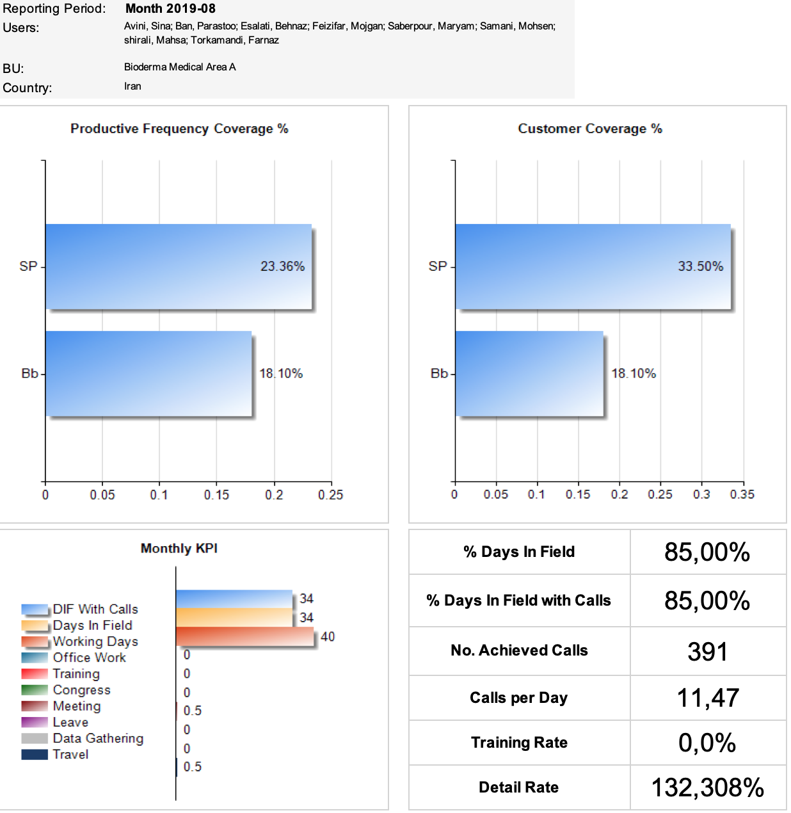

1. iPad / Android Client:

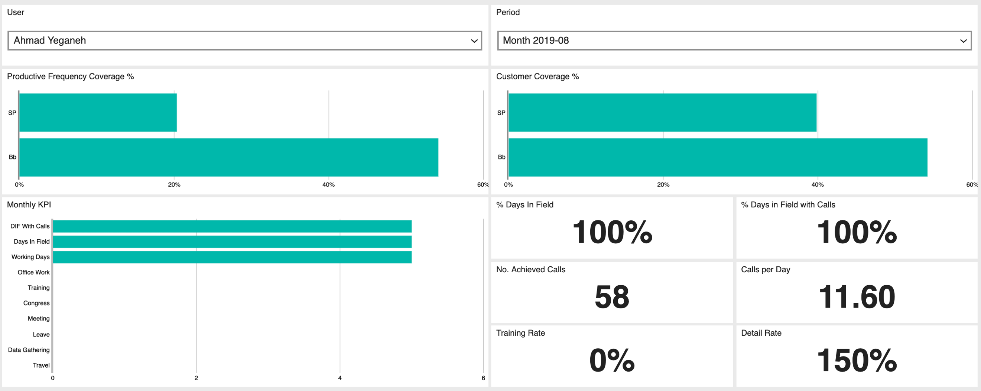

## “ETE Report” Specifications

### Location:

to be displayed on Web Reports.

### Contents:

This report contains two tables (1-2) with the following parameters:

1. Small Table (top) displays the following, displayed as either value (max. 2 decimals) or percentage (%) by BU, Area, User (Manager), and Type:
   1. Working Days
   2. Available Time for Coaching
   3. Coaching Calls
   4. Total Coaching Days
   5. Coaching (%)
2. Large Table (bottom) contains the following, displayed as either value (max. 2 decimals) or percentage (%), by BU, Area, and User (Representative):
   1. Working Days
   2. Days in Field
   3. % Days in Field (%)
   4. Days in Field with Calls
   5. % Days in Field with Calls (%)
   6. No. Achieved Calls
   7. Planned Calls
   8. % Achieved Calls (%)
   9. Calls on Target
   10. Calls per Day
   11. % Call Rate Achievement
   12. Detail Rate
   13. Coverage of Customers (by Tier)
   14. Productive Frequency (by Tier)
   15. Average Reporting Interval (displayed as time: HH:MM)

### Report Attributes per Device:

1. **Web Reports** are intended for users with rights to view country-level data, and allow data to be filtered by Line, User (SLM, TL, Rep) by name, and by Period (month).

### Layout / Screenshots: Table

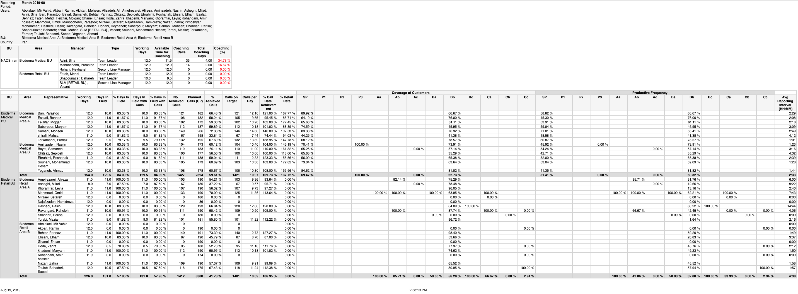

## “First Opened Day” Specifications

### Location:

to be displayed on Web Reports.

### Contents:

This report contains 1 table with the following parameters:

* 1. User Name (format: print name)
  2. Login Name (format: firstname.lastname; based on email address)
  3. User Type (Rep, SLM, Team Leader, Super User)
  4. First Open Day (format: date: YYYY-MM-DD)

### Device attributes:

1. **Web Reports** are intended for users with rights to view country-level data. This report does not allow filtering, but displays the current FOD status of each user listed.

### Layout / Screenshots: Table

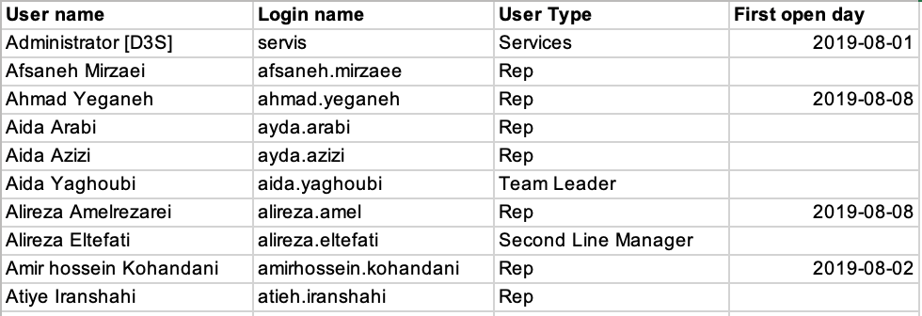

## “Matrix Report: Key Messages” Specifications

### Location:

to be displayed on Web Reports.

### Contents:

This report contains 1 table with the following parameters:

* 1. **BU** (name of Business Unit)
  2. **SLM** (sortname of FLM)
  3. **Team Leader** (sortname of TL)
  4. **Representative** (sortname of rep)
  5. **Customer** (sortname of customer)
  6. **Priority** (customer rating - variable per BU)
  7. **Specialty** (customer specialization)
  8. **Date** (date and time call report was submitted)
  9. **Promoted Product** (displays text of a question from Call Report, e.g. “What was your first promoted product?”)
  10. **Answer** (displays selected answer option from the above question)
  11. **Key Message** (displays text of the questions from Call Report, e.g. “What key messages did you deliver for this product?” + “What was the doctor's reaction to the key message? in separate cells)
  12. **Answer** (selected answer options from the above questions)

### Report attributes:

1. The table will include collapsed rows that can be expanded on click. Data will be grouped as follows:  
   1. Representative
      1. Customer
         1. Date
2. Data from call reports will be grouped by date
3. The report is designed to read call reports dynamically:  
   1. Promoted Product questions and answers are taken from any questions that include the phrase “promoted product” within their text
   2. Key Message questions and answers are taken from any questions that include the phrase “key message” within their text
   3. keyword queries are not case sensitive, and search within words, so use of capitalization or plural forms will not affect the reliability of the query

### Device attributes:

1. **Web Reports** are intended for users with rights to view country-level data. This report allows filtering by date (date from/to, by month), org unit (BU, Area), and User (representative) and displays the status of key messages delivered and their reaction per each reported interaction. Data are drawn from Call Reports where users record whether they have delivered key messages (yes/no) and the customers’ reactions during visits.

### Layout / Screenshots: Table

1. Collapsed view

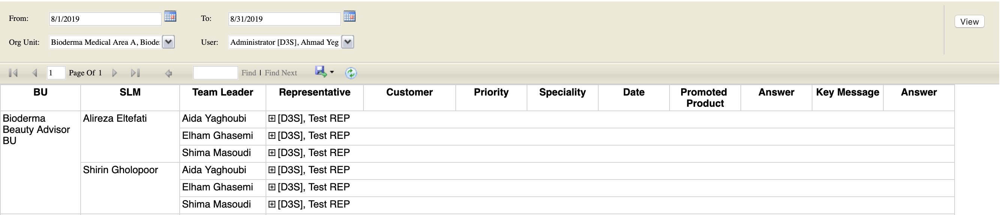

1. Partially expanded view

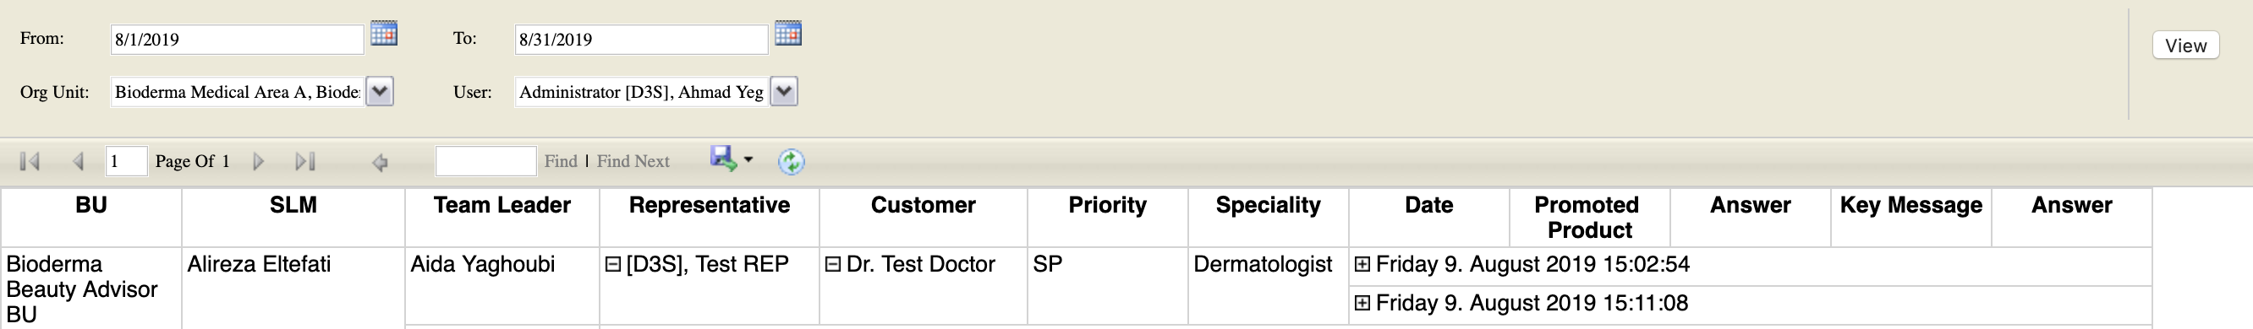

1. Fully Expanded view

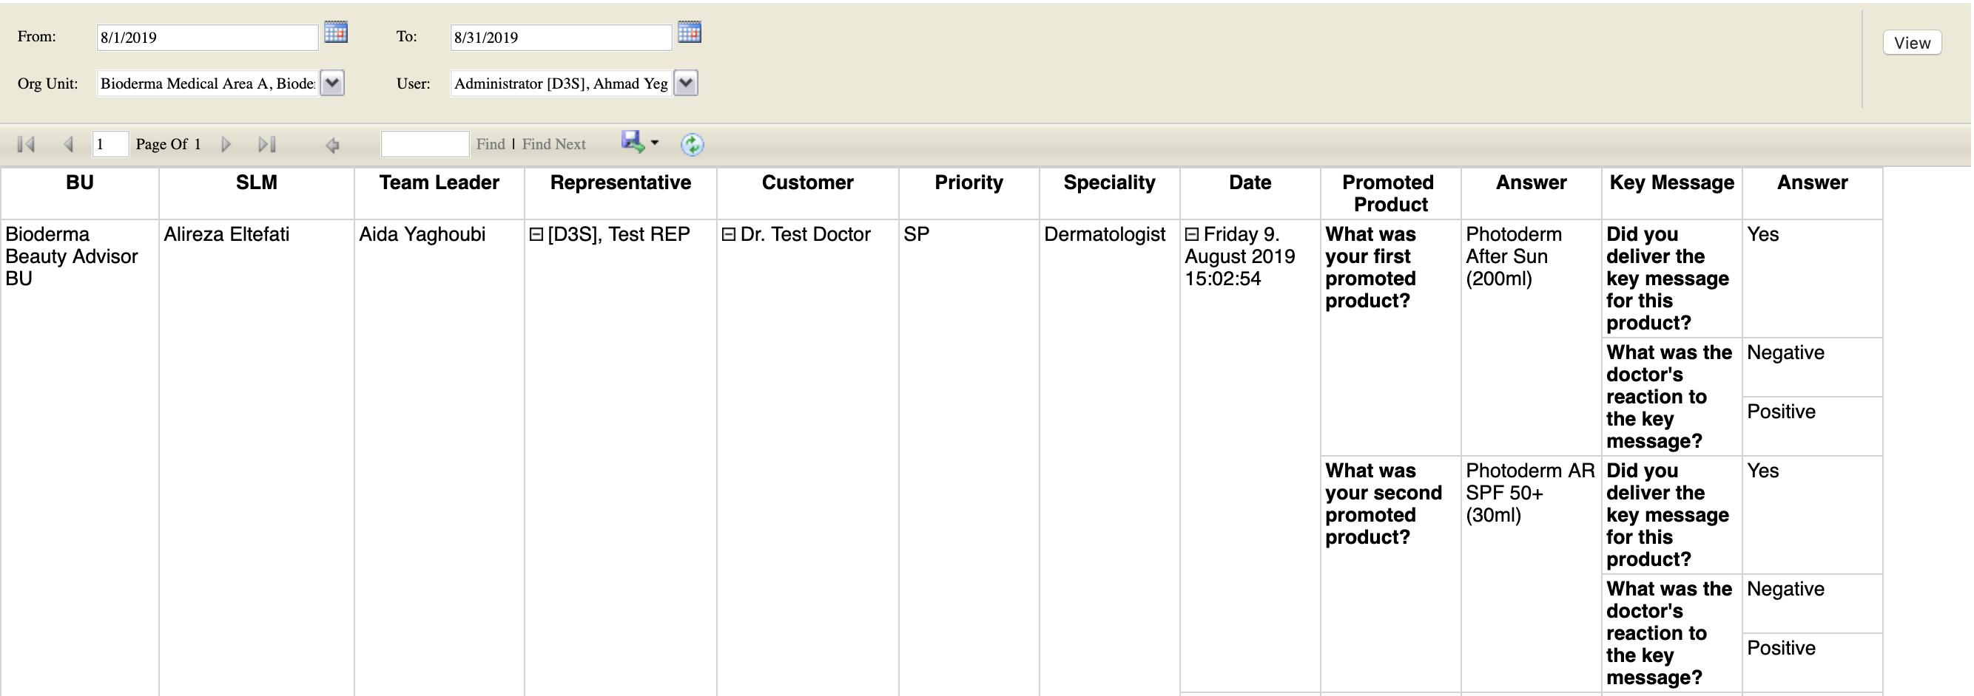

## “Cycle Plan Review” Specifications

### Location: Web Reports

### Contents:

This report contains 1 table with the following parameters:

* 1. Business Unit (based on Org. Units)
  2. Area (based on Org. Units)
  3. User Type (BUH, FLM, HQ, Nurse Adviser, PM, Rep, SLM, Super User, Team Leader)
  4. User (format: print name)
  5. Entity (workplace or institution; same as Person if no other workplace identified)
  6. Person (individual customer)
  7. Address (street address)
  8. Specialization1 (assigned primary spec.)
  9. City (name of city)
  10. District (name of district)
  11. Status of Cycle Plan (status options: Approved, Created, Opened, Requests Approval)
  12. Status of Cycle Plan Item (status options: Approved, Created, Opened, Requests Approval)
  13. Is In Target Group (format: 1/0 = yes/no)
  14. Is In Cycle Plan (format: 1/0 = yes/no)
  15. Rating (current)
  16. Rating (new)
  17. Frequency (current) (format: whole number)
  18. Frequency (new) (format: whole number)
  19. Note (format: free text)
  20. Changed By (format: User Device Type ID /or/ User ID)
  21. Changed (format: Date: [weekday name], [month name] DD, YYYY, HH:MM AM/PM)
  22. Rating Name (format: [BU/Area name] - Tier)

### Device attributes:

1. **Web Reports** are intended for users with rights to view country-level data. This report allows data to be filtered by Target Group (period), Org Units (BU, Area), Status of Cycle Plan, User Type, and by User (by name), with multi- and non-contiguous period (month) selection supported.

### Layout / Screenshots: Table

## “BA Sales Plan Performance” Specifications

### Location: Web Reports

### Contents:

This report contains 1 table with the following parameters:

1. Filters  
   1. Activity Type
   2. Product group
   3. Org Unit
   4. User
   5. Period (From / To - via date picker)
   6. POS
2. Table
   1. Date
   2. Team Leader
   3. Representative
   4. POS
   5. Plan Type
   6. Product Group
   7. Plan (= daily target for planned pharmacy, variable)
   8. Deficit (= Plan MINUS Actual)
   9. % Achievement (Actual DIVIDED BY Plan)
   10. Product SKU
   11. Actual (= total no. pieces scanned)

### Device attributes:

1. **Web Reports** are intended for users with rights to view country-level data. This report allows data to be filtered by Activity Type, Product Group, Org Unit (BU, Area), User (by name) and period, with custom date range selection supported.

### Layout / Screenshots: Table

## “BA Dashboard” Specifications

### Location: Native Client (Android)

### Contents:

This report contains numeric gauges and one table with the following parameters:

1. Gauges: (displaying aggregated values and averages for all Product Groups)  
   1. Monthly Target
   2. Actual Sales
   3. Percentage Achievement (= Actual DIVIDED BY Target)
   4. Remaining Quantity (= Target MINUS Actual)
2. Table: (displaying values by Product Group)  
   1. Product Group
   2. Monthly Target
   3. Actual Sales
   4. Percentage Achievement (= Actual DIVIDED BY Target)
   5. Remaining Quantity (= Target MINUS Actual)

### Device attributes:

1. **Native Client Dashboards** are intended for users with the role Rep and allow data to be filtered by period (month)

### Layout / Screenshots: Dashboard

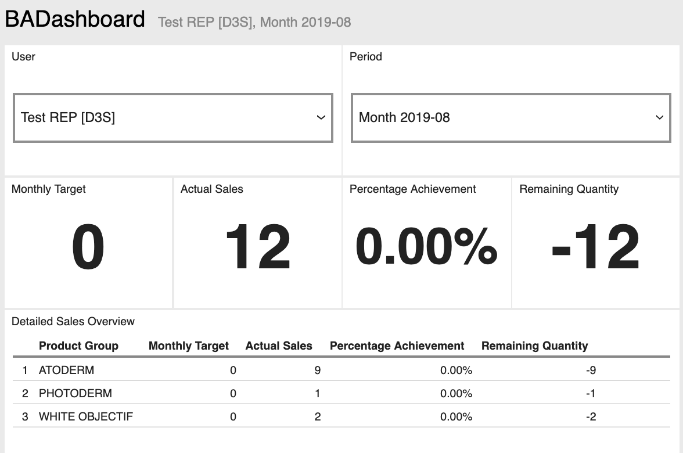

## “GPS Location Compliance” Specifications

### Location: Web Reports

### Contents:

This report contains 1 table with the following parameters:

1. Filters
   1. Org Unit
   2. REP (user)
   3. Radius (m)
   4. Date From
   5. Date To
2. Table (columns):
   1. Date
   2. Org. Unit
   3. User
   4. POS
   5. Location (cell contains the following:)
      1. Actual (format: GPS coordinate)
      2. POS (format: GPS coordinate)
   6. Location Timestamp (format: MM/DD/YYYY , HH:MM:SS AM/PM)
   7. Transaction Timestamp (format: MM/DD/YYYY , HH:MM:SS AM/PM)
   8. Difference (format: HH:MM:SS)
   9. Distance (M)

In the Location column both actual location of where transaction was submitted (as “Actual”) and the location of the POS (as “POS”) are displayed. The Distance value is highlighted by a red font if it exceeds the value in the Radius filter. Default Radius value is 500 m.

### Device attributes:

1. **Web Reports** are intended for users with rights to view country-level data. This report allows data to be filtered by Org Unit (BU, Area), Rep (user, by name), radius (distance from target), and custom date range (from/to).

### Layout / Screenshots: Table

### 

## “Monthly Distribution Tracker” Specifications

On a monthly basis, the CRM Coordinator / SFE /Delegate will receive a report displaying the samples received by customers during the previous month. This report will help flag customer for whom the limit will be reached and hence to communicate with the SLM/CEM to ensure coordination between responsible Medical representatives to ensure limit is not exceeded.

**Layout:**

|  |  |  |  |  |  |  |
| --- | --- | --- | --- | --- | --- | --- |
| **Monthly Sample Distribution Tracker** | | | | | | |
| **Customer Type**  ***(Person / Inst. Type)*** | **Customer  Name**  ***(Print name of Pers. or Inst.)*** | **Med Rep First Name** | **Med Rep Last Name** | **Sample submitted in [Month]** | | **Total Distributed Samples/Year** |
| **Date of Delivery** | **Number of Samples** |

## 

## “Monthly Samples Reconciliation” Specifications

On a running basis, the CRM Coordinator / SFE / Delegate will receive a report reflecting the samples recieved per customer. This Report will read profiles stating the max. sample limit for a specific customer as well as the transaction history in order to provide the remaining balance of sample allocation possible for the customer.

**Layout:**

|  |  |  |  |  |  |  |  |  |
| --- | --- | --- | --- | --- | --- | --- | --- | --- |
| **Monthly Samples Reconciliation Report** | | | | | | | | |
| **Representative** | **SKU** | **Batch No.** | **Expiration Date** | **Carryover + Received** | **Carryover** | **Received / month** | **Distributed / month** | **Balance** |

## “Sample Acknowledgement Letters” Specifications

On a running basis, the CRM Coordinator / SFE / Delegate will receive a report containing the sample acknowledgment letters signed by each HCP (as specified in Sec. 5 of this specification)

**Layout:**

|  |  |  |  |  |  |
| --- | --- | --- | --- | --- | --- |
| **Sample Acknowledgement Letters** | | | | | |
| **Representative** | **Customer** | **Address** | **Status** | **Visit Date** | **Link (PDF)** |

## “Sample Recall Distribution Report” Specifications

On a running basis, a report will provide information required for sample recall. It will allow the report user to filter all distributed samples within a user-defined period by SKU and Batch No. in order to view a list of all HCPs who have received samples for recall.

**Layout:**

|  |  |  |  |  |  |  |
| --- | --- | --- | --- | --- | --- | --- |
| **Distribution Report for Sample Recall - Persons** | | | | | | |
| **SKU** | **Batch No.** | **Expiry Date** | **HCP**  **Print Name** | **Workplace** | **Med Rep Print Name** | **Distributed Quantity** |

|  |  |  |  |  |  |
| --- | --- | --- | --- | --- | --- |
| **Distribution Report for Sample Recall - Institutions** | | | | | |
| **SKU** | **Batch No.** | **Expiry Date** | **Institution**  **Print Name** | **Med Rep Print Name** | **Distributed Quantity** |

## “Rep WH Stock Transfer Report” Specifications

On a running basis, the CRM Coordinator / SFE / Delegate will receive a report containing the WH Transfer letters signed by each representative upon accepting stock transfers from the central warehouse (as specified in Sec. 6. of this specification).

**Layout:**

|  |  |  |  |  |  |
| --- | --- | --- | --- | --- | --- |
| **Rep WH Transfer Receipts** | | | | | |
| **Transfer Date** | **Manager** | **Representative** | **SKUs** | **Status** | **Link (PDF)** |

# Sample Acknowledgement Letter

The following is a description of the Sample Acknowledgement Letter. It contains fixed and variable text to be added by the system based on the transaction date, target, workplace location of the target, and samples dispensed. Text in red refers to the information the system will add to the PDF automatically based on user inputs and customer selection. There are two letter formats, one for (a) persons and another for (b) institutions.

## Content of the Letter - Persons

**LETTER OF ACKNOWLEDGEMENT TO BE SIGNED BY HCP UPON RECEIVING SAMPLES**

**Date:** [embed transaction date: dd/mm/yyyy]

**Representative:** [embed user print name]

**Subject:** Receipt of Free Medical Samples

To whom this may concern,

[embed print name]

I Dr. ____________________________ hereby acknowledges receipt of the following samples as per the description set out below:

|  |  |  |  |  |
| --- | --- | --- | --- | --- |
| Brand | Product Description | No. Packs | Batch No. | Expiry Date |
| (brand) | (SKU incl. pack size) | (no. pieces issued) | (batch/lot) | (expiry) |

I confirm that the samples received have been received by me as “Free Medical

Samples” and are not for re-sale.

[embed signature]

----------------------------

Sincerely

Name [embed print name]

Date [embed transaction date: dd/mm/yyyy]

## Content of the Letter - Institutions

**LETTER OF ACKNOWLEDGEMENT TO BE SIGNED BY POS EMPLOYEE UPON RECEIVING SAMPLES**

**Date:** [embed transaction date: dd/mm/yyyy]

**Representative:** [embed user print name]

**Subject:** Receipt of Free Medical Samples

To whom this may concern,

[embed institution name]

An employee working at ______________________________ has signed receipt of the following samples as per the description set out below:

|  |  |  |  |  |
| --- | --- | --- | --- | --- |
| Brand | Product Description | No. Packs | Batch No. | Expiry Date |
| (brand) | (SKU incl. pack size) | (no. pieces issued) | (batch/lot) | (expiry) |

The signatory, as the authorized representative of this business, understands and accepts that the samples received have been received as “FreeMedicalSamples” and are not for re-sale.

[embed signature]

----------------------------

Date [embed transaction date: dd/mm/yyyy]

# Rep WH Transfer Receipt

The following is a description of the Sample Acknowledgement Letter signed by reps after confirming acceptance of a stock transfer from the central warehouse. It contains fixed and variable text to be added by the system based on the transaction date, manager, recipient, and samples dispensed. Text in red refers to the information the system will add to the PDF automatically based on user inputs and customer selection. There are two letter formats, one for (a) persons and another for (b) institutions.

## Content of the Letter - Representatives

**LETTER OF ACKNOWLEDGEMENT TO BE SIGNED BY REPRESENTATIVE UPON RECEIVING SAMPLES**

**Date:** [embed transaction date: dd/mm/yyyy]

**Representative:** [embed user print name]

**Subject:** Receipt of Free Medical Samples

To whom this may concern,

I confirm I have received the following samples as per the description set out below:

|  |  |  |  |  |  |
| --- | --- | --- | --- | --- | --- |
| Brand | Product Description | Price | No. Packs | Batch No. | Expiry Date |
| (brand) | (SKU incl. pack size) | (SKU price from price list) | (no. pieces issued) | (batch/lot) | (expiry) |

The signatory, as the authorized representative of this business, understands and accepts that the samples received have been received as “FreeMedicalSamples” and are not for re-sale.

[embed signature]

----------------------------

Date: [embed transaction date: dd/mm/yyyy]